**Name:** Atif Ansari

**Roll No:** 04

**Div:** D15B

**Experiment 1**

**Aim:** To understand the benefits of cloud infrastructure and set up AWS Cloud9 IDE, launch it, and perform a collaboration demonstration.

**Theory**:

**Cloud Infrastructure:** Cloud infrastructure refers to the combination of hardware, software, networking, and storage that together create a cloud computing platform. It allows businesses to leverage resources like computing power, storage, and networking as per demand, without investing in physical infrastructure. Key cloud infrastructure providers include AWS, Google Cloud, and Microsoft Azure.

**Benefits of Cloud Infrastructure:**

1. **Scalability:** Easily scale resources up or down based on demand without upfront investment in hardware.
2. **Cost Efficiency:** Pay-as-you-go model reduces capital expenses, paying only for what you use.
3. **Flexibility and Accessibility:** Access services and resources from anywhere with an internet connection, promoting remote work and global reach.
4. **Reliability:** High availability and disaster recovery options ensure that services are available with minimal downtime.
5. **Security:** Cloud providers offer advanced security measures, including data encryption, compliance certifications, and continuous monitoring.
6. **Innovation:** Rapid deployment of new services and features accelerates innovation and business agility.

**AWS Cloud9 IDE:** AWS Cloud9 is a cloud-based integrated development environment (IDE) that allows developers to write, run, and debug code with just a browser. It supports a variety of programming languages, including JavaScript, Python, PHP, and more, making it an ideal tool for collaborative software development.

**Benefits of AWS Cloud9:**

1. **Collaborative Development:** Multiple developers can work on the same project in real-time, making it ideal for pair programming and team collaboration.
2. **Preconfigured Environment:** No need for complex setup; Cloud9 comes pre-installed with tools, libraries, and compilers needed for most development tasks.
3. **Accessible from Anywhere:** As a web-based IDE, it can be accessed from any device with an internet connection.
4. **Integrated with AWS:** Deep integration with AWS services allows developers to work seamlessly with cloud resources.
5. **Built-in Terminal:** Direct access to a terminal with full sudo privileges to manage AWS resources and run shell commands.

**Collaboration Demonstration in AWS Cloud9:** AWS Cloud9 allows multiple users to simultaneously edit code, chat, and review changes in real-time. To demonstrate collaboration:

* Invite team members via email or link.
* Collaborate on code, view changes in real-time, and chat within the IDE.
* Use version control systems like Git integrated within Cloud9 for better collaboration and tracking of changes.

**Outputs:**

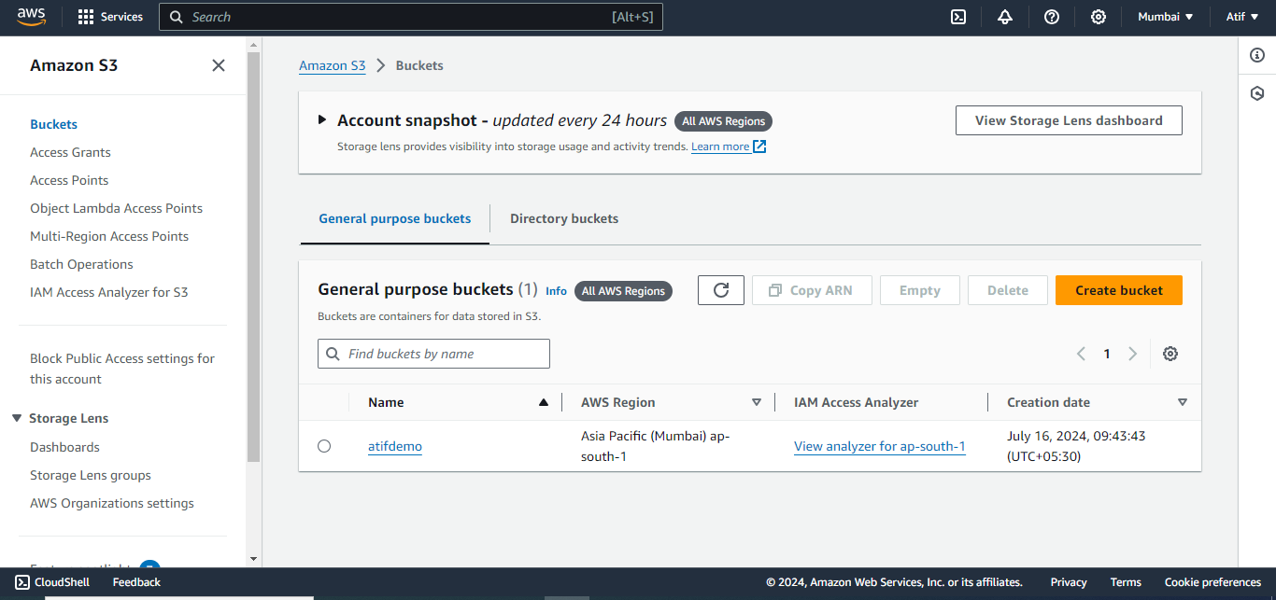

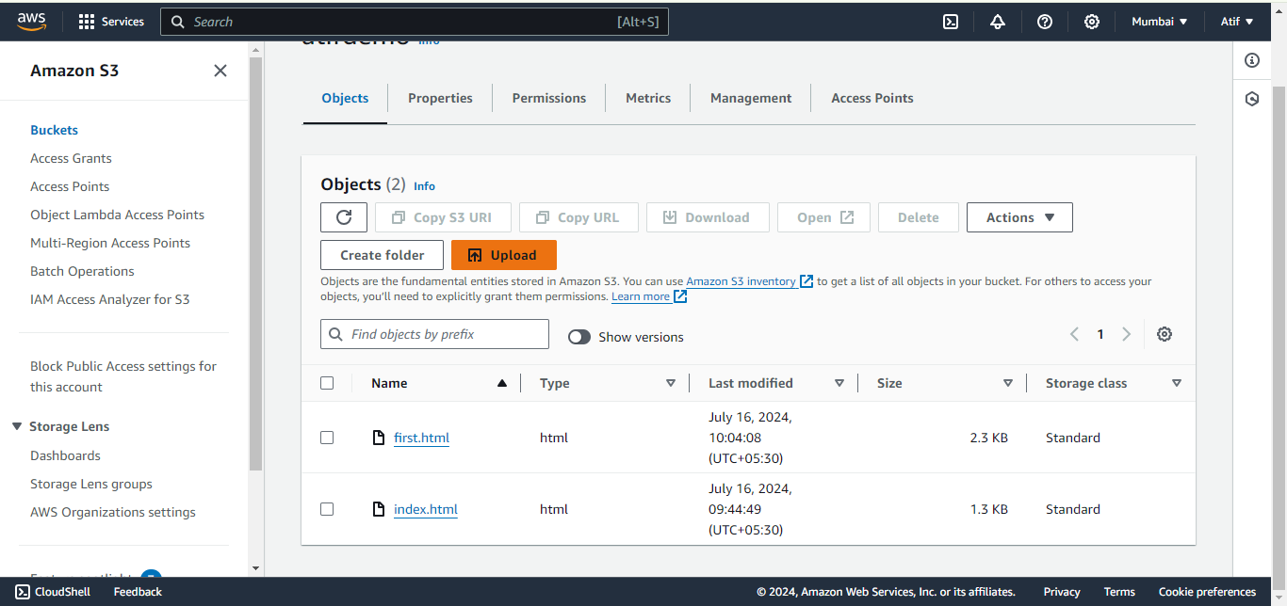

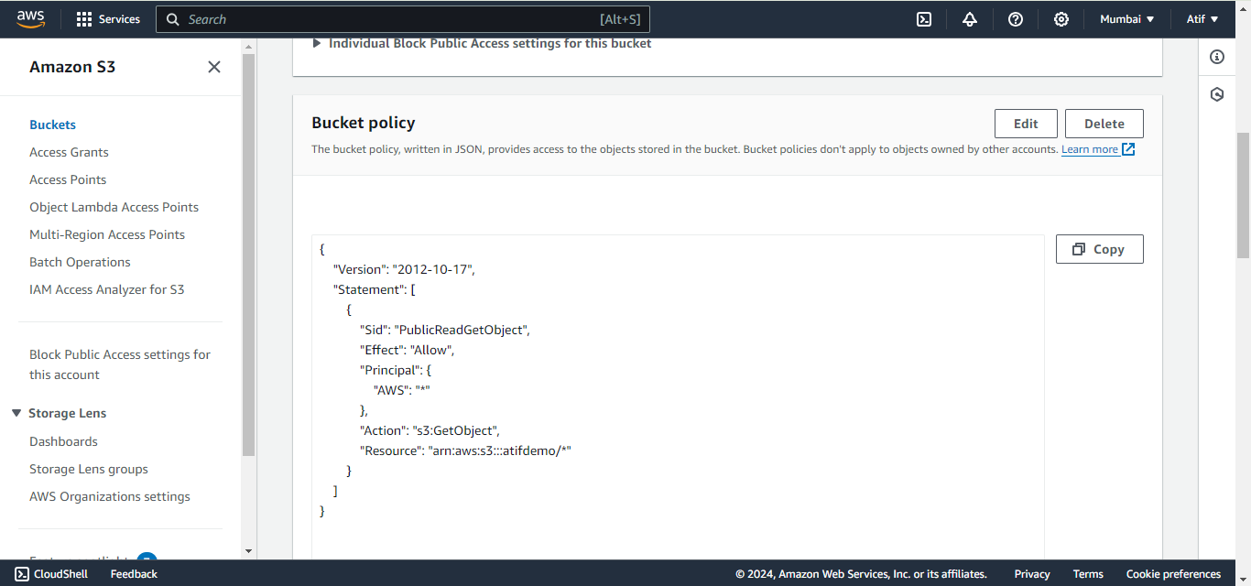

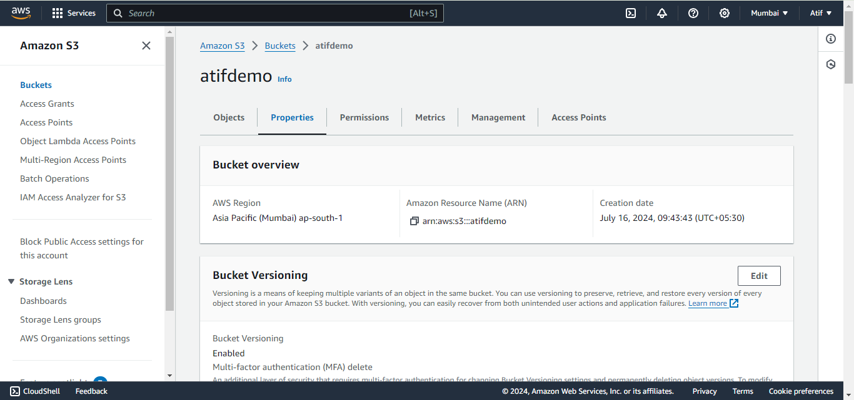

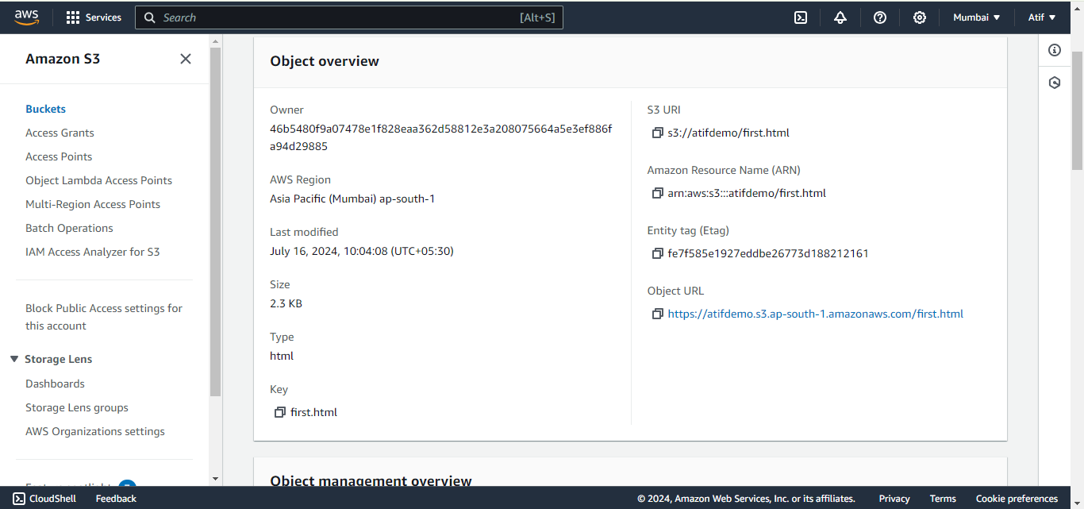

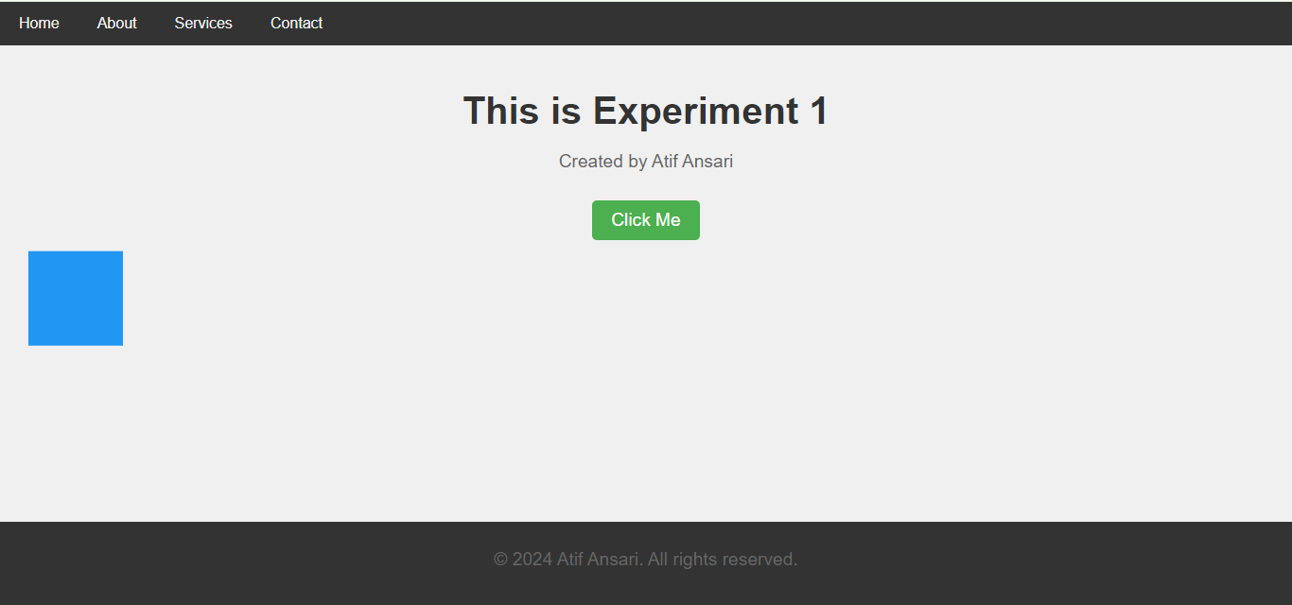

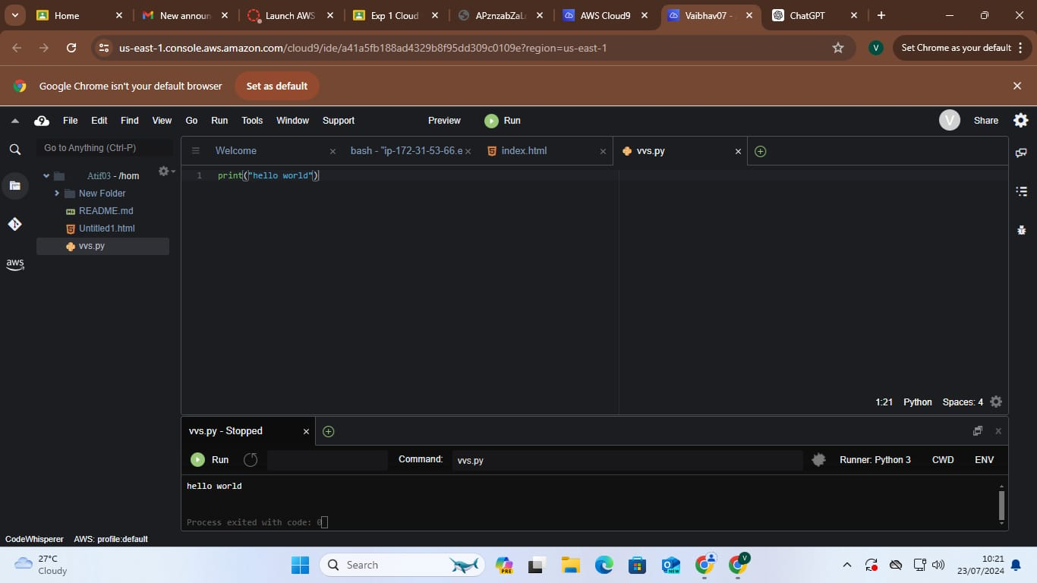

**Conclusion:**

Understanding cloud infrastructure is essential for leveraging the power of modern computing. AWS Cloud9 provides a robust, cloud-based IDE that enhances the software development process by offering a pre-configured environment, accessibility, and collaborative features. Setting up AWS Cloud9 and demonstrating its collaborative capabilities shows how teams can efficiently work together, making the development process faster and more streamlined. The hands-on experience with AWS Cloud9 highlights the practical benefits of cloud infrastructure and collaborative development tools in the modern software industry.